PROJECT DESIGN PHASE II

|  |  |
| --- | --- |
| DATE | 17.10.2022 |
| TEAM ID | PNT2022TMID51453 |
| PROJECT TITLE | CRUDE OIL PRICE PREDICTION |
|  |  |

DATA FLOW DIAGRAM

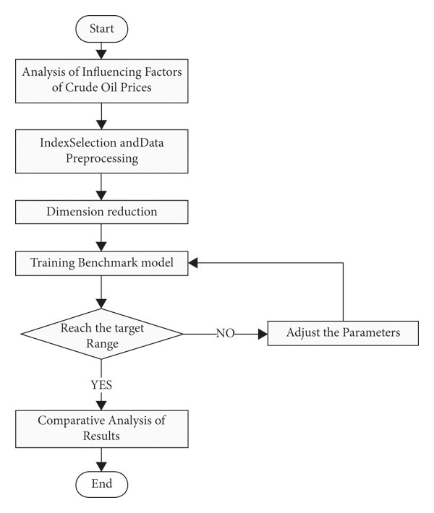

FUNCTIONAL REQUIREMENTS

User Stories : Use the below template to list all the user stories for the product.

|  |  |  |  |
| --- | --- | --- | --- |
| User Type User Story / Task | Type Functional Requirement (Epic) | User Story Number | User Story /Task |
| Predictors | Data analysis and collection | USN-1 | AS A USER I CAN ANALYSIS OF influencing factors of curde oil price through various web pages |
|  |  | USN-2 | Data samples are collected from various web sites |
|  |  | USN-3 | The collected data will be proceed to remove the raw data from the data site |
|  | Pre-processing | USN-4 | The preprocessed data will be put in for the training and splitting |
|  | Training model | USN-5 | The trained data will be checked for the target page that is set by user |
|  |  | USN-6 | If user range is not yet meet again the data is put in for training |
|  |  | USN-7 | Attempt is made until the range is reached |
|  | Predicted value | USN-8 | Once the range is reached will be compared with previous result to obtain the correct predicted value |